Smart Habit Tracker
using Object-Oriented Programming

Title of Project | Smart Habit Tracker using Object-Oriented Programming
Course Name | Application Development Using Design Concepts
Student Name(s) | Iraiarulanandha Sachithanandham,  Soorya Thejus S, Naitik Kankariya
Register Number | RA2511026011382, RA2511026011384,  RA2511026011385
Class / Section | 1003/Z2
Faculty Name | Prathiba S
Institution Name | SRM INSTITUTE OF SCIENCE AND TECHNOLOGY
Academic Year | 2025-2026

2. Abstract
The Smart Habit Tracker is a console-based application developed in C++ that allows users to create, monitor, and maintain daily habits. The application tracks the user's name, stores a list of habits, marks habits as completed each day, and maintains a streak counter to encourage consistency.
The core problem this project addresses is the lack of a simple, structured digital tool for personal habit management that simultaneously demonstrates Object-Oriented Programming concepts. By using four well-defined classes — User, Habit, DailyHabit, and Tracker — the application models real-world entities in a clean, maintainable structure.
The application is built entirely in C++ using only standard libraries (iostream, vector, string). Key features include a menu-driven interface, streak tracking, habit completion marking, and runtime polymorphism via virtual function override. The project demonstrates all four OOP pillars: Encapsulation, Inheritance, Polymorphism, and Abstraction.

3. Introduction
3.1 Background
In today's fast-paced world, maintaining good habits is one of the most effective strategies for personal growth. However, without a structured system to track daily habits, people often lose motivation and consistency. Habit-tracking applications have become increasingly popular — tools like Habitica, Streaks, and Google Tasks are used by millions worldwide. These applications, at their core, are built using the same object-oriented principles taught in first-year programming courses.
3.2 Need for the System
While many commercial habit trackers exist, they are complex and difficult to study from a programming perspective. A simple, code-transparent habit tracker built in C++ allows students to see exactly how OOP concepts — classes, inheritance, and polymorphism — power a real application. This project fills that need by providing a working, minimal, and well-documented implementation.
3.3 Objectives
- Apply all four OOP pillars in a real working C++ application.
- Design a clean class hierarchy: User, Habit, DailyHabit (derived), and Tracker.
- Build a functional menu-driven program for adding, completing, and viewing habits.
- Demonstrate runtime polymorphism using virtual functions and method overriding.
- Write beginner-friendly, commented code under 150 lines using only basic libraries.

3.4 Scope
The application operates as a single-session, in-memory console program. It does not use file handling or a database, keeping the scope focused on OOP demonstration. The system supports adding multiple habits, marking them complete, tracking streaks, and displaying all habits — all through a numbered menu.

4. OOP Concepts Used
This section explains how each of the four OOP pillars is applied in the Smart Habit Tracker. Small code snippets are included to illustrate each concept.

4.1 Encapsulation
Encapsulation is the bundling of data (attributes) with the functions that operate on them, and restricting direct external access using access specifiers. In the Habit class, all three core attributes are declared private so that no code outside the class can read or modify them directly — only controlled public methods are exposed.

class Habit {
private:
string habitName;
int streak;
bool completedToday;
public:
string getName(){
return habitName;
}
Int getStreak(){
return streak;
}
void setCompleted(bool v){
completedToday = v; }
};

4.2 Inheritance
Inheritance allows a derived (child) class to automatically acquire the attributes and methods of a base (parent) class, enabling code reuse without rewriting. In this project, DailyHabit inherits from Habit. It gains all of Habit's attributes — habitName, streak, completedToday — while only adding one new attribute of its own: reminderTime.

class DailyHabit : public Habit {
private:
string reminderTime;
public:
DailyHabit(string name, string time) : Habit(name), reminderTime(time) {}
string getReminderTime(){
return reminderTime;
}
};

4.3 Polymorphism
Polymorphism means the same function name behaves differently depending on which object calls it. The Habit base class declares markComplete() as a virtual function. DailyHabit then overrides this function to print a custom message that also shows the reminder time. At runtime, C++ automatically calls the correct overridden version.

// In Habit (base class):
virtual void markComplete() {
if (!completedToday) { completedToday=true; streak++; }
}

// In DailyHabit (overrides):
void markComplete() override {
setCompleted(true);
incrementStreak();
cout << "Done! (" << reminderTime << ") Streak: " << getStreak();
}

4.4 Abstraction
Abstraction hides internal complexity and exposes only what is necessary. The Tracker class manages a vector<DailyHabit> list internally, but outside code never touches this vector directly. Instead, three simple public methods form the entire interface, hiding all implementation details.

class Tracker {
private:
vector<DailyHabit> habits;
public:
void addHabit(string name, string time);
void completeHabit(int index);
void showHabits();
};

4.5 Classes and Objects
A class is a blueprint and an object is an instance of that blueprint. This project defines four classes:

Class | Type | Role
User | Standalone | Stores name; greets the user
Habit | Base class | Core data: habitName, streak, completedToday
DailyHabit | Derived | Extends Habit; adds reminderTime; overrides markComplete()
Tracker | Manager | Hides habit list; provides add, complete, show interface

5. System Analysis
5.1 Existing System
Currently, most students track habits using paper planners, basic spreadsheets, or commercial mobile apps. While these tools work for end users, they do not expose their internal structure, making them unsuitable as learning tools for programming concepts.
5.2 Limitations of Existing System
- Paper planners and spreadsheets do not demonstrate programming concepts.
- Commercial apps are too complex for a first-year student to analyse or modify.
- No freely available, minimal C++ habit tracker exists that clearly illustrates OOP.
- Existing C++ examples are either too simplistic (no OOP) or too advanced (file I/O, templates, pointers).

5.3 Proposed System
The Smart Habit Tracker is a console application that solves all the above limitations. It is written in clean, readable C++ using only basic libraries. It uses four classes with clear responsibilities, demonstrates all four OOP pillars, and operates through a simple numbered menu — making it ideal for students to study, present, and extend.
5.4 Advantages
- Demonstrates Encapsulation, Inheritance, Polymorphism, and Abstraction in one program.
- Under 150 lines — easy to read, understand, and present in a viva.
- No external dependencies — compiles with any standard C++11 or later compiler.
- Streak tracking provides a realistic, engaging feature that mirrors real-world apps.
- Easily extendable — can add file saving, categories, or a GUI in future semesters.

6. System Design Using UML
UML (Unified Modelling Language) is a standard visual language for planning and communicating software structure. Three diagrams are used in this project to capture different aspects of the system.

6a. Use Case Diagram
The use case diagram shows what the Student (actor) can do with the system. Each ellipse represents one interaction. The dashed arrow between 'Mark habit as complete' and 'View habits' is an «include» relationship, meaning viewing the list is a required step inside the completion flow.

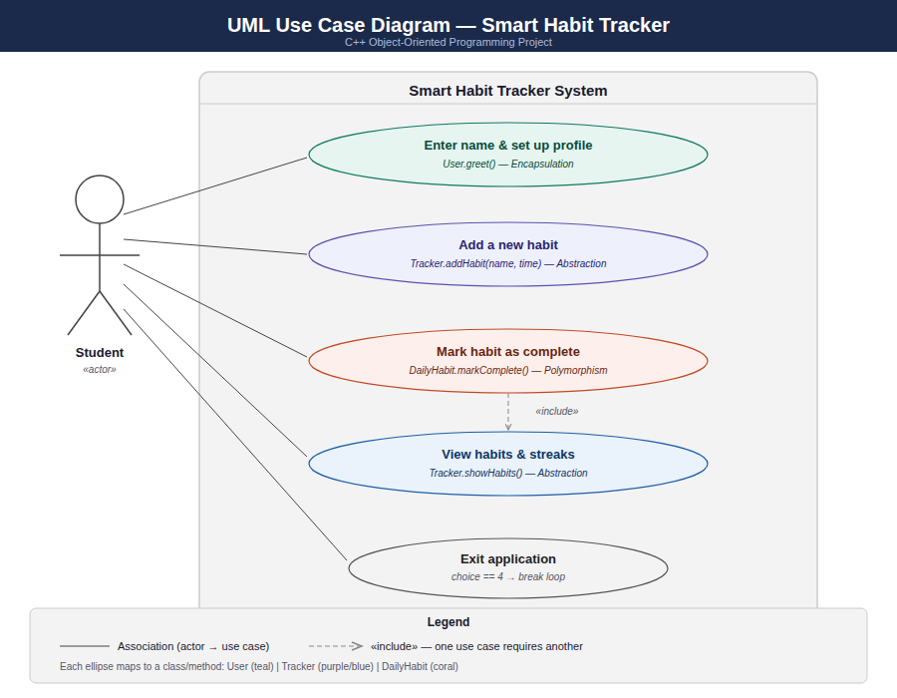
Figure 1: Use Case Diagram — Smart Habit Tracker

6b. Class Diagram
The class diagram shows all four classes, their private (-) and public (+) members, and the relationships between them. DailyHabit inherits from Habit (solid arrow with hollow triangle). Tracker uses DailyHabit internally (dashed arrow). Virtual functions are shown in italic.

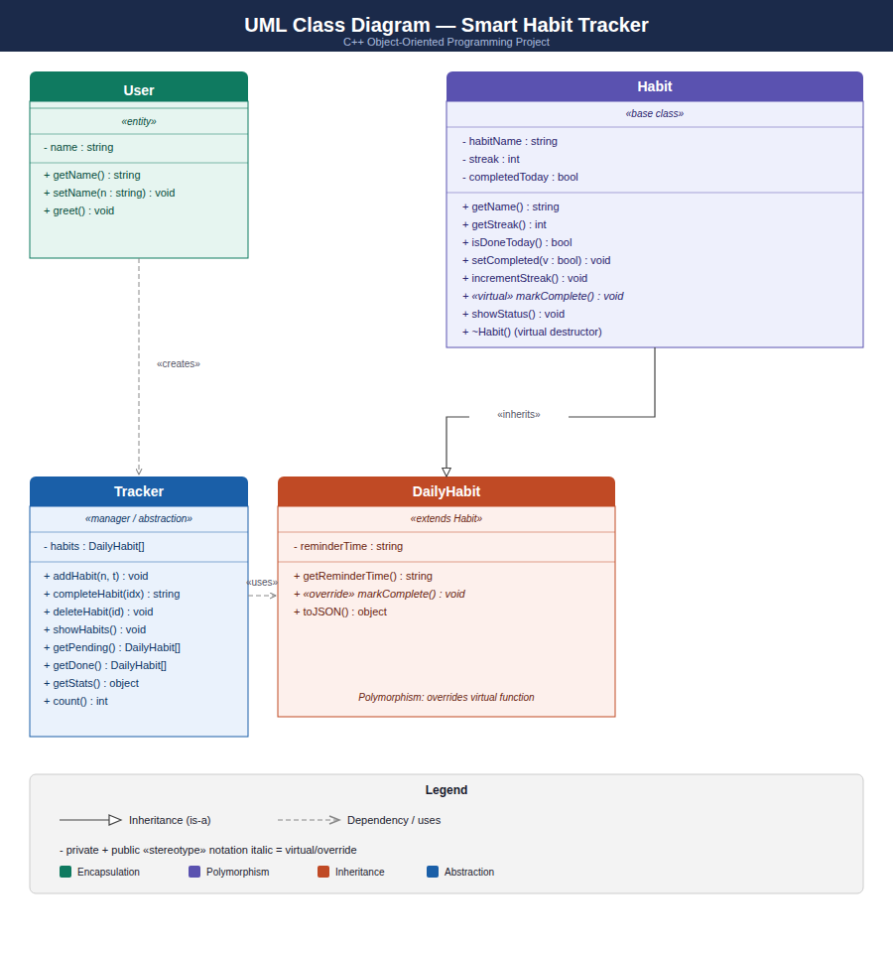
Figure 2: Class Diagram — Smart Habit Tracker

6c. Sequence Diagram
The sequence diagram traces the exact message flow between objects when the student selects option 2 (mark habit complete) from the menu. Solid arrows show method calls; dashed arrows show return values. Steps 8–13 are the most critical — this is where polymorphism (DailyHabit.markComplete() override) and encapsulation (private setter calls) both activate simultaneously.

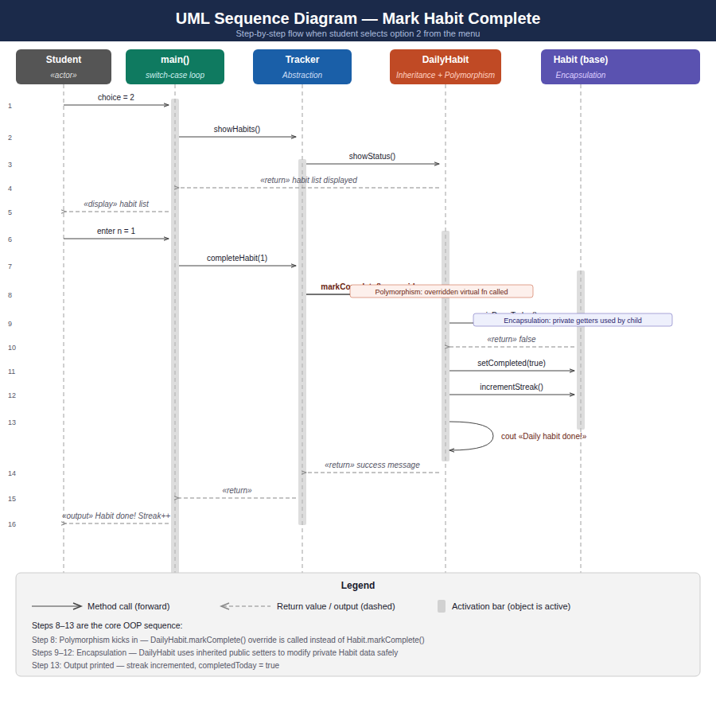
Figure 3: Sequence Diagram — Mark Habit Complete Flow

7. Implementation Details
7.1 Programming Language and Tools
- Language: C++ (standard C++11 or later)
- Libraries: <iostream>, <vector>, <string> — no external dependencies
- IDE: Any standard IDE (Code::Blocks, VS Code, Dev-C++, or terminal with g++)
- Compiler: g++ (GNU C++ Compiler) | Compile command: g++ -std=c++11 habit.cpp -o habit

7.2 Module Descriptions

Module 1 — User Module: The User class stores the student's name as a private attribute. It exposes getName() for reading and greet() to print a personalised welcome message. This module demonstrates Encapsulation by keeping the name private and only allowing controlled access.
Module 2 — Habit Management Module: The Habit base class and DailyHabit derived class together handle all habit data. Habit stores habitName, streak, and completedToday privately. DailyHabit extends this with reminderTime and overrides markComplete() to display the reminder alongside the completion message. This module demonstrates Inheritance and Polymorphism.
Module 3 — Tracker / Data Management Module: The Tracker class acts as the central manager. It maintains a private vector<DailyHabit> list and provides three public methods for adding, completing, and displaying habits. The internal vector is never accessible from outside — this is Abstraction in action.
Module 4 — Main Menu Module: The main() function drives the program using a do-while loop and a switch-case statement. It creates one User and one Tracker object, then repeatedly displays the menu until the user chooses to exit.

7.3 Key Code Snippet — Main Menu

int main() {
string userName;
cout << "Enter your name: ";
getline(cin, userName);
User user(userName);
Tracker tracker;
user.greet();
int choice;
int choice;

do {
cout << "\n===== Habit Tracker Menu =====\n";
cout << "1. Add a habit\n";
cout << "2. Mark habit as completed\n";
cout << "3. Show all habits\n";
cout << "4. Exit\n";
cout << "Enter choice: ";
cin >> choice;
cin.ignore();

switch (choice) {

case 1: {
string hName, hTime;
cout << " Habit name: ";
getline(cin, hName);
cout << " Reminder time (e.g. 7:00 AM): ";
getline(cin, hTime);
tracker.addHabit(hName, hTime);
break;
}

case 2: {
tracker.showHabits();
if (tracker.count() > 0) {
int n;
cout << " Habit number to complete: ";
cin >> n;
cin.ignore();
tracker.completeHabit(n);
}
break;
}

case 3:
tracker.showHabits();
break;

case 4:
cout << "Goodbye!\n";
break;

default:
cout << “Invalid choice. Please enter 1-4.\n";
}

} while (choice!= 4);
8. Output Screens / Results
Two complete sample runs of the program are shown below, demonstrating the menu, habit addition, completion, streak tracking, and the already-completed guard.

Run 1 — Adding Habits and Viewing Status

Enter your name: Priya

Welcome, Priya! Let's track your habits.

===== Habit Tracker Menu =====
1. Add a habit
2. Mark habit as completed
3. Show all habits
4. Exit
Enter choice: 1
Habit name: Morning Run
Reminder time: 6:30 AM
Habit "Morning Run" added (reminder: 6:30 AM)

Enter choice: 1
Habit name: Read 20 pages
Reminder time: 9:00 PM
Habit "Read 20 pages" added (reminder: 9:00 PM)

Enter choice: 3
--- Your Habits ---
1. [ ] Morning Run | Streak: 0 day(s)
2. [ ] Read 20 pages | Streak: 0 day(s)
-------------------

Enter choice: 4
Goodbye, Priya! Keep it up!

Run 2 — Completing Habits and Checking Streaks

Enter your name: Arjun

Welcome, Arjun! Let's track your habits.

Enter choice: 1
Habit name: Meditate
Reminder time: 7:00 AM
Habit "Meditate" added (reminder: 7:00 AM)

Enter choice: 2
--- Your Habits ---
1. [ ] Meditate | Streak: 0 day(s)
-------------------
Habit number to complete: 1
Daily habit "Meditate" done! (Reminder: 7:00 AM) Streak: 1

Enter choice: 2
--- Your Habits ---
1. [DONE] Meditate | Streak: 1 day(s)
-------------------
Habit number to complete: 1
Already completed today.

Enter choice: 3
--- Your Habits ---
1. [DONE] Meditate | Streak: 1 day(s)
-------------------

Enter choice: 4
Goodbye, Arjun! Keep it up!

9. Testing
The following test cases verify the core functionality of the Smart Habit Tracker. All tests were executed manually using the console menu.

# | Test Case | Input | Expected Output | Result
1 | Enter student name | Priya | Welcome, Priya! Let's track your habits. | Pass
2 | Add a habit | Morning Run / 6:30 AM | Habit added confirmation message | Pass
3 | Mark habit complete | choice=2, n=1 | Daily habit done! Streak: 1 | Pass
4 | Mark same habit again | choice=2, n=1 | Already completed today. | Pass
5 | View all habits | choice=3 | List with [DONE] and streak count | Pass
6 | Invalid menu choice | choice=9 | Invalid choice. Try again. | Pass
7 | Invalid habit number | n=99 | Invalid habit number. | Pass
8 | Exit application | choice=4 | Goodbye, <name>! Keep it up! | Pass

10. Features & Enhancements
10.1 Key Features Implemented
- Personalised user greeting via the User class.
- Add unlimited habits with a name and reminder time.
- Mark habits as complete — each marks completedToday = true and streak++.
- Guard against double-completion — the already-completed-today check.
- View all habits with DONE / blank status and streak count.
- Clean class hierarchy with virtual function and override demonstrating runtime polymorphism.
- Full menu-driven interface using do-while and switch-case.

10.2 Possible Future Improvements
- File handling — save habits to a .txt or .csv file so streaks persist across runs.
- Date-aware streaks — reset completedToday automatically at midnight using <ctime>.
- Habit categories — Health, Productivity, Mind — with filtering in the menu.
- Reminders — print habits whose reminder time matches the current system time.
- GUI — port the application to a simple Qt or SFML window for a desktop experience.
- Multiple users — extend the User class to support a list of user profiles.

11. Conclusion
The Smart Habit Tracker project successfully demonstrates how Object-Oriented Programming principles can be applied to design and build a real, functional application in C++. Through the development of this project, all four OOP pillars were used meaningfully rather than just theoretically:

- Encapsulation was achieved by keeping Habit's core data private and exposing it only through controlled public methods.
- Inheritance was demonstrated by DailyHabit extending Habit, reusing all its attributes and logic while adding only what was new.
- Polymorphism was shown through the virtual markComplete() function being overridden in DailyHabit to print custom output.
- Abstraction was implemented in the Tracker class, which hides the internal vector<DailyHabit> list behind a clean three-method interface.

This project also highlighted the importance of UML diagrams in software design. The class diagram, use case diagram, and sequence diagram together provide a complete visual understanding of the system before even reading a single line of code — a skill that is fundamental to professional software development.
As a learning outcome, this project bridges the gap between classroom theory and real application development, giving students confidence to design, code, and present an OOP application from scratch.

12. References

Books
- E. Balagurusamy, Object Oriented Programming with C++ (6th Edition), Tata McGraw-Hill, 2013.
- Bjarne Stroustrup, The C++ Programming Language (4th Edition), Addison-Wesley, 2013.
- Herbert Schildt, C++: The Complete Reference (4th Edition), McGraw-Hill, 2003.
Websites
- GeeksforGeeks — C++ OOP Concepts. https://www.geeksforgeeks.org/object-oriented-programming-in-cpp/
- TutorialsPoint — C++ Inheritance. https://www.tutorialspoint.com/cplusplus/cpp_inheritance.htm
- cplusplus.com — Classes Tutorial. https://cplusplus.com/doc/tutorial/classes/
- LearnCpp.com — Beginner OOP Guide. https://www.learncpp.com/

